2nd Grade

New Spelling Words
Consonant Blends
nest spend strong frog stick
past spring scrap blog brick
High Frequency Words
sound things more
Last Week’s Highlights
Spelling Test on Friday

This Week’s Homework
Monday: Spelling
Tuesday: Reading Log
Wednesday: Math Facts Log
Thursday: Reading Log
Friday: Spelling Test/Poetry Binder

Notes
*We hope you enjoyed watching the Virtual Open House presentation last week.
*Thank you to all who wore red, white and blue on Friday for Patriot Day!
*Progress reports were available to see on Skyward last Friday.
*Thank you for sending addressed/stamped envelopes to school for Grandparent’s Day. The kids had a great time mailing them.
*We have started full days here at FGS! ☺ Dismissal time is 2:30 p.m.
*Now that we have started full days, we do have P.E. everyday. There is room in our classroom for tennis shoes, if you need to send them with your child.
*Thank you to all who have already donated snacks for snack time. A note came home last week about sending in things for snack. Also, remember to send a water bottle each day.

Monday, September 14, 2020

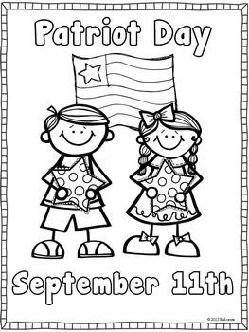

Last Week’s Highlights

No School – Labor Day

Monday

In Reading last week, students enjoyed the story Maybe Something Beautiful How Art Transformed a Neighborhood. We learned more about what makes a text realistic fiction. Last week we focused on what authors tell us about characters.

Tuesday

Last week we practiced CVCe words. (Consonant-Vowel-Consonant-silent e) We learned that these words have a long vowel sound. Ex: time, lake, erase, etc.

Wednesday

In Math we have finished Module one and have moved on to Module Two: Addition and Subtraction of Length Units. We used centimeter cubes to measure lengths of objects.

Thursday

We made Grandparents Day cards for our grandparents. We wore patriotic colors and learned about Patriot Day.

Friday

